Name : MUHAMMAD MUBASHAR ALI

Student ID : BSIET02213012

Subject : Object Oriented Programming .

Lab : 10

Example # 01

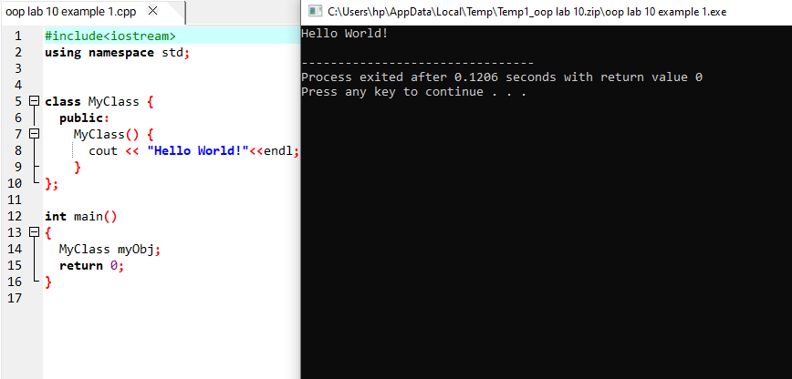

Example # 02

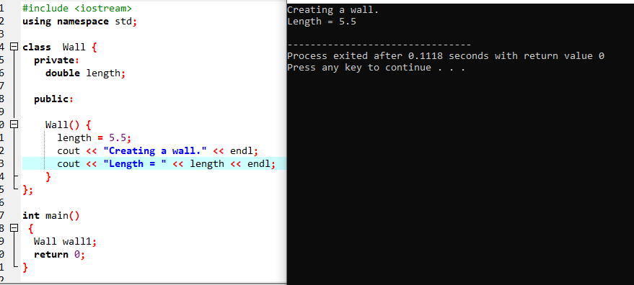

Example # 03

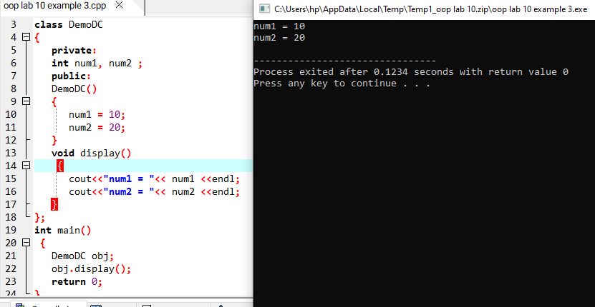

Example # 04

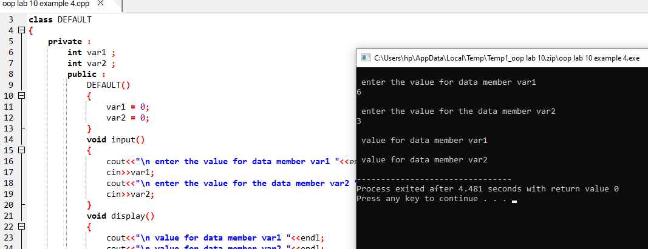

Example # 05

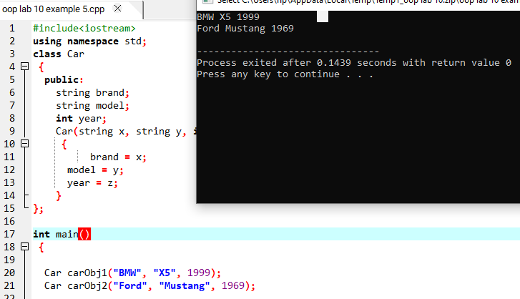

Example # 06

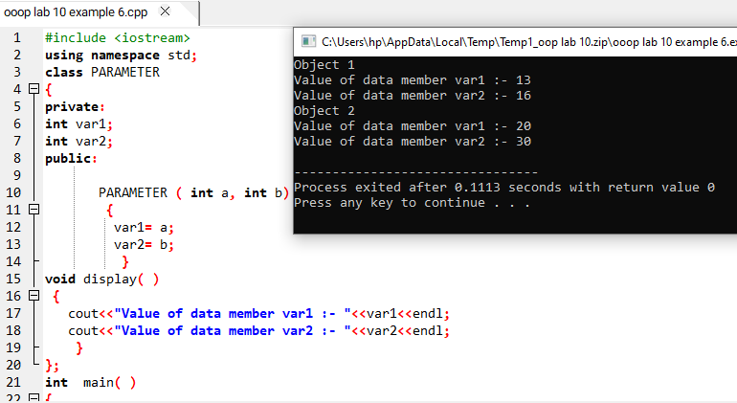

Example #07

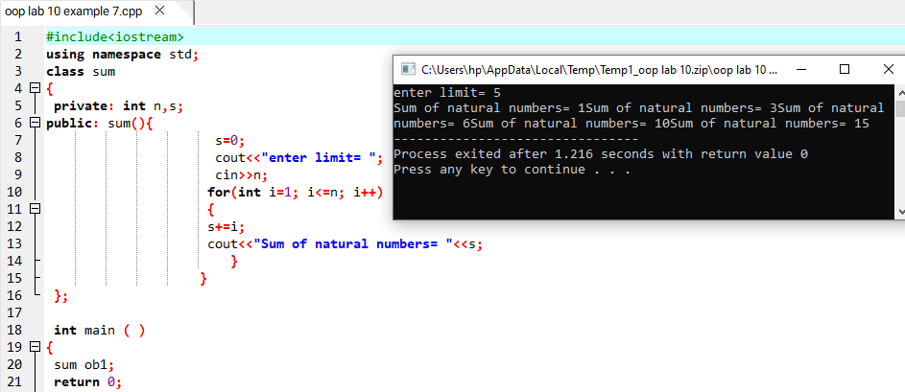

Example # 08

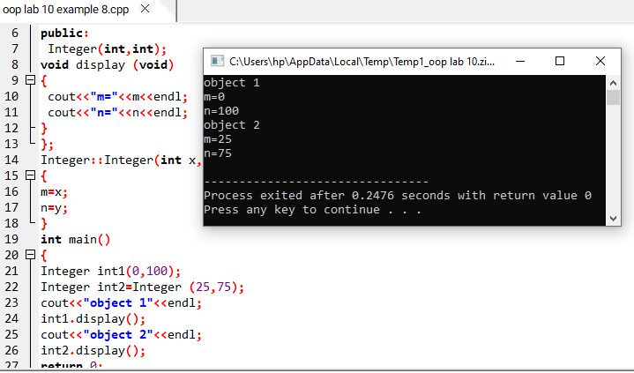

Example # 09

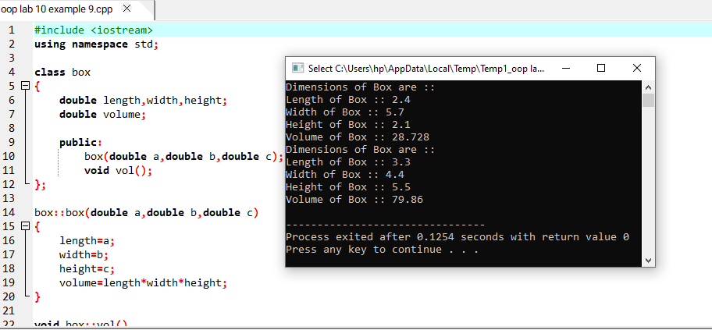

Reviews Questions

Question # 01

Solved all lab exercise questions and check their output to your instructor ?

Answer

All done

Question # 02

What is constructor?. It is mandatory to use constructor in class?

Answer

A constructor is a special method of a class or structure in object-oriented programming that initializes a newly created object of that type. Whenever an object is created, the constructor is called automatically. It is mandatory to have a constructor with the right access modifier. However, the compiler supplies a default if an access modifier is not defined in the class and a constructor is not declared.

Question # 03

What are the special properties of constructor function?

Answer

Constructor functions are invoked automatically when the objects are created. No return type can be specified for a constructor. A constructor may not be static. They cannot be inherited though a derived class can call the base class constructor. It is not possible to take the address of a constructors. Constructors should be declared in the public section to be accessible to all the functions. Constructors can have default arguments as other C++ functions.

Question # 04

Write a program in C++ to find out the area of rectangle using constructor ?

Answer

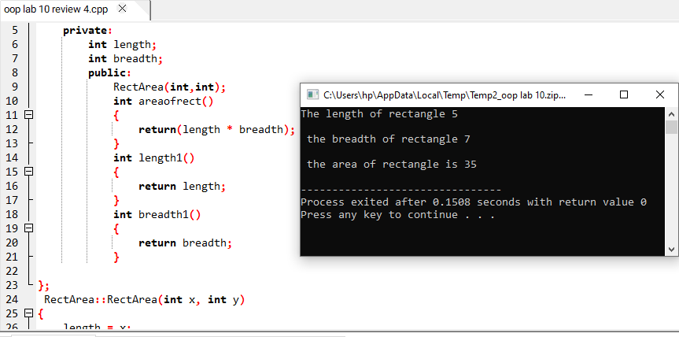

Question # 05

Write a program in C++ to find out the volume of cube using constructor ?

Answer

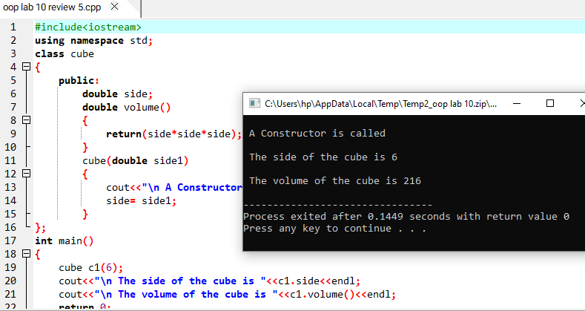

Question # 06

Write a program in C++ to show counter function using constructor. The output should be like this

|  |
| --- |
| Before calling Counter Function, Count = 0  After calling Counter Function, Count = 1  Process returned 0 |

Answer

